Solution Architecture:

|  |  |
| --- | --- |
| Date | 30 September 2022 |
| Team ID | PNT2022TMID08727 |
| Project Name | IoT based smart crop protection system for agriculture |
| Maximum Marks | 4 Marks |

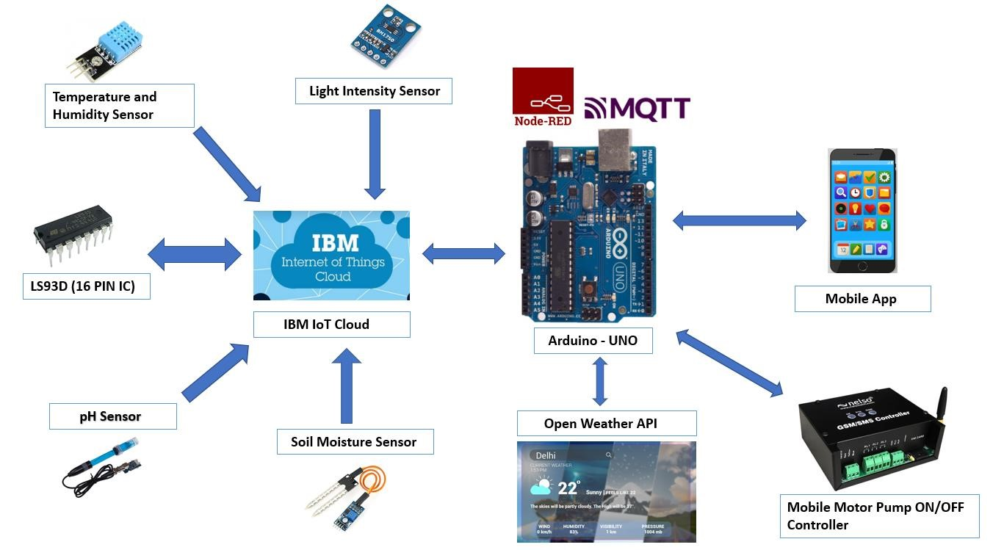

Key points:

•The different soil parameters (temperature, humidity, light intensity, pH level) are sensed using different sensors and the obtained value is stored in IBM cloud.

•Arduino uno is used as a processing unit which processes the data obtained from sensors and weather data from weather API.

•Node red is used as a programming tool to wire the hardware, software and APIs. The MQTT protocol is followed for communication.

•All the collected data are provided to the user through a mobile application which was developed. Depending upon the sensor values, Mobile Motor Pump controller waters the crop.